The Mongolian Empire

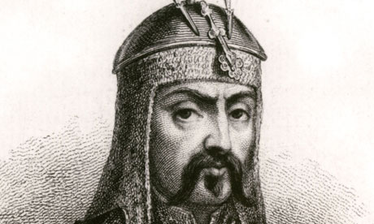
A man named Temujin, later known as Genghis Khan, was the man who united many tribes of modern day Mongolia. These nomadic tribes were united in 1206 when Temujin claimed the title of Khan, leader of all Mongolians. The Mongolians would later create the largest land empire in the history of the world. There are many different views of Genghis Khan. Mongolians take pride in their historic leader, however many people including many Chinese, Persian (Iran), and Russians describe Genghis Khans as a destructive monster who committed terrible acts of mass murder and destruction.
The destruction caused by the Mongol Empire is a fact. Between the 1200’s and the mid 1400’s it is estimated that the Mongols killed around 40 million. The military plan of “surrender or die”—and sometimes those who surrendered would be killed to serve as an example to other people. Also, when invading an area, the Mongols would do whatever it took to conquer a town such as: diverting rivers to cut off water, block food supplies and burn farmland, kill most of the people and let some go to the next city so that they can report the destruction.
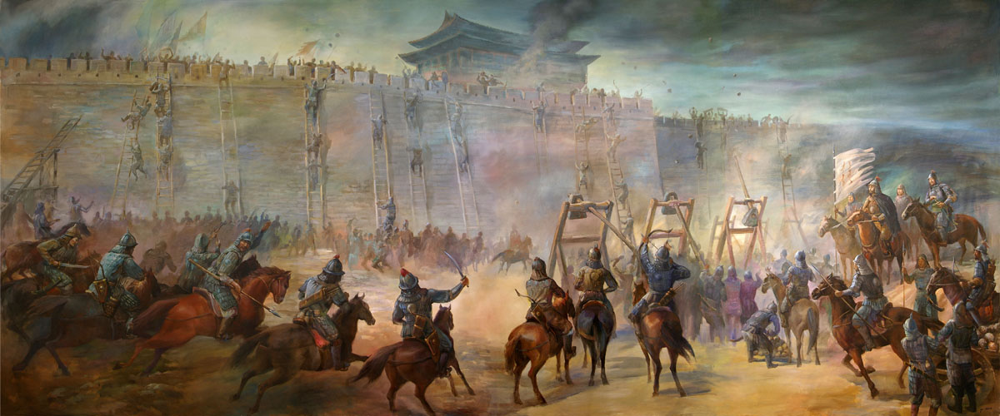
Horses were the main factor that made the Mongol army so strong. Each Mongol soldier had at least one or two horses. Most armies at this time had maybe 25% of their army on horseback. The primary weapon of the Mongol forces was the Mongol bow. At the time no other type of bow compared in regard to accuracy, force, and reach. It is believed that most soldiers could hit their target from nearly 100 yards—though the bow would easily fire arrows over 400 yards. So, Mongolians would “soften” the enemy from 400 yards away with thousands of wildly shot arrows coming down like rain, then charge in and finish the job once the enemy was confused and scattered.
Mongol horses were small, but their riders wore light armor and moved with great speed. The Mongolian people were nomadic herders, so they were constantly on horseback. The soldiers were men who grew up on horses and used their bow every day in hunting making them nearly as trained as professional soldiers. Most armies at this time had only a few professional soldiers—such as knights—with a majority of the army made of peasant farmers with only a few days of training. The Mongolians, on the other hand, trained every soldier, every day. They all trained in archery, horseback combat, hand-to-hand combat, formation attacks, and military strategies.

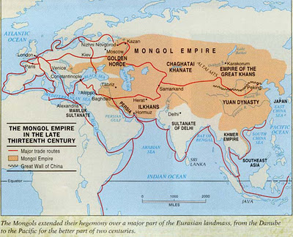
Mongols were experts in laying siege (attacking forts, walled cities, or other “safe” places). Technology was one of the important parts of Mongolian warfare. For instance, siege machines, such as catapults, siege towers, and the battering ram were an important part of Genghis Khan's warfare. The siege engines were disassembled and were carried on horses to be rebuilt at the site of the battle. The engineers building the machines were taken mostly from China and Persia. One of the Great Khan’s favorite things to do was to gather innocent civilians from the nearby areas and force them to attack a walled city to save their own troops, basically using them as "human shields". Another favorite siege attack was catapulting flaming diseased bodies into a walled city or catapulting poison food for people who are starving inside the walls.

The first real defeat came in the Battle of Ain Jalut in 1260 after nearly 60 years of undefeated victory. This battle took place in modern day Israel against Egyptian Muslims called Mamluks. That battle ended the western expansion of the Mongolian Empire, and within the next 20 years the Mongols also suffered defeats in attempted invasions of Vietnam and Japan, but that did not end the empire. In fact, the Mongolian Empire would last until about1400 when the fighting of civil wars finally ended the large empire.
Synonym/Definition | Word from reading
1. fighting
2. main
3. growth
4. roaming
5. throwing
6. attacking
7. taken apart

8. Who is Temujin? _____________________________________
9. What does the idea “surrender or die” mean?

______________________________________________________
10. What made the Mongol army so strong?

__________________________________________________________________________________________________

11. How far could be shot at enemies?

__________________________________________________________________________________________________

12. How was the Mongolian army different from China’s army?

__________________________________________________________________________________________________

13. What were two of the strategies used by the Mongols during war?

__________________________________________________________________________________________________

14. What happened as a result of the Mongols invasion of Vietnam and Japan?

__________________________________________________________________________________________________

15. What events occurred to bring the Mongolian Empire to an end?

__________________________________________________________________________________________________

16. Why might many people from China describe Genghis Khan as “a destructive monster who committed terrible acts of mass murder and destruction?”

__________________________________________________________________________________________________

17. How long did the rule of the Mongolian Empire last? ___________________________________________________

